Airbus IaC – 2i10-suse repository

Document Owner: Ghanshyam Swami (DXC technology)

Version: 1.0

Published on: 28.04.2023



Project Name: AIRBUS

Document Status (e.g. Draft, Final and Archived): Initial

Document Revision History

|  |  |  |  |  |  |  |
| --- | --- | --- | --- | --- | --- | --- |
| Change Request# (Optional) | Document Version | Date | Prepared / Modified by | Reviewed by | Approved by | Section and Text Revised |
|  | 1.0 | 28-Apr-2023 | Ghanshyam Swami |  |  | Initial version |
|  |  |  |  |  |  |  |
|  |  |  |  |  |  |  |
|  |  |  |  |  |  |  |

**Table of Contents**

Purpose 4

Repository Structure 4

EC2 Deployed 7

Jenkins jobs 8

How to build – A high level Overview 9

Features Delivered 10

SSM Documents for GEA 10

SSM Documents for GEH 12

SSM Documents for JEA 13

# Purpose

This document is about 2i10-suse repository in Airbus GitHub. This repository is used to build ABAP distributed system for non-prod environment and standalone SAPRouter in AWS.

# Repository Structure

2i10-suse

Configuration\applications\sap

arp-gea -> code to build SAP ABAP distributed system in non-prod

arp-geh -> code to build SAP ABAP distributed system in non-prod

modules -> submodules for different AWS resource provisioning

sap-router-jea -> code for standalone router

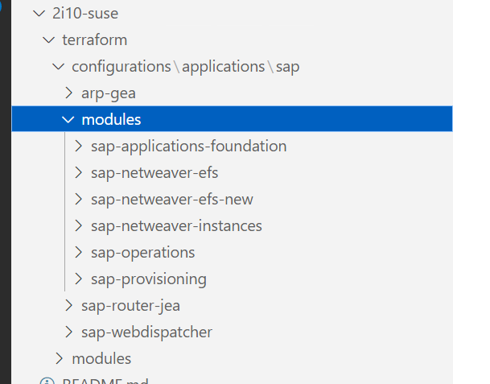

Different terraform files inside application folder arp-gea, which contains input tfvars, backend, Jenkinsfile, main, version, variable, output, provider etc.

* main.tf - call modules, locals, and data sources to create all resources
* variables.tf - contains declarations of variables used in main.tf
* outputs.tf - contains outputs from the resources created in main.tf
* versions.tf - contains version requirements for Terraform and providers
* terraform.tfvars should not be used anywhere except [composition](/key-concepts#composition).
* A version.tf file for version of terraform tool
* A provider.tf file for cloud provider being used

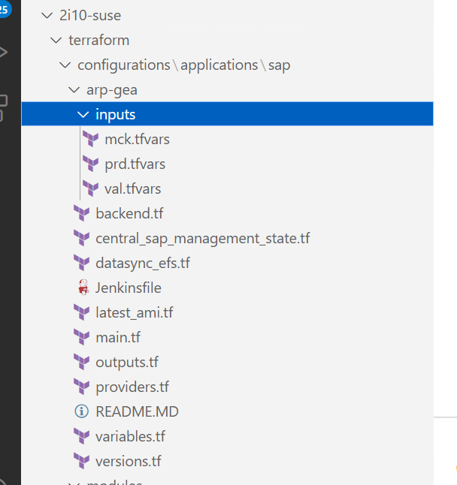

sap-router-jea ->

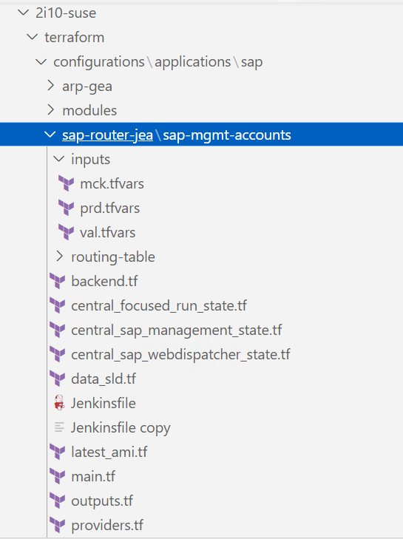

AWS Standard modules:

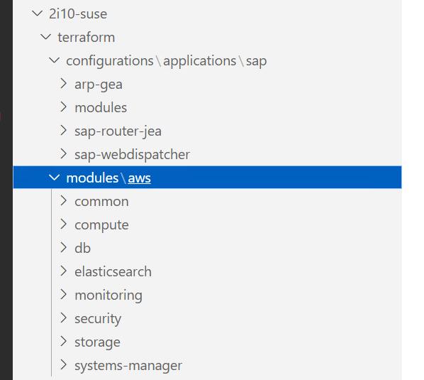

# EC2 Deployed

GEA: 3 EC2 servers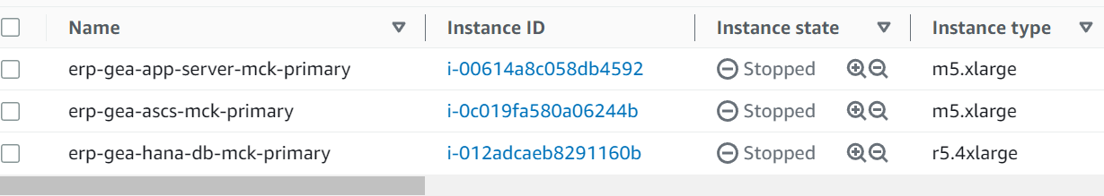

GEH: 3 EC2 servers

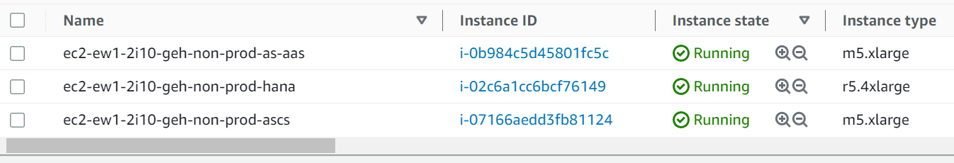

JEA: 1 EC2 server

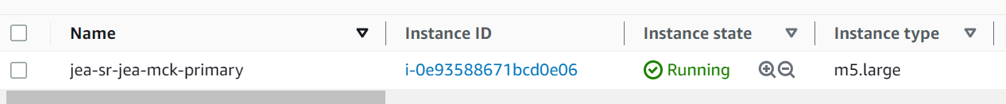

Volumes:

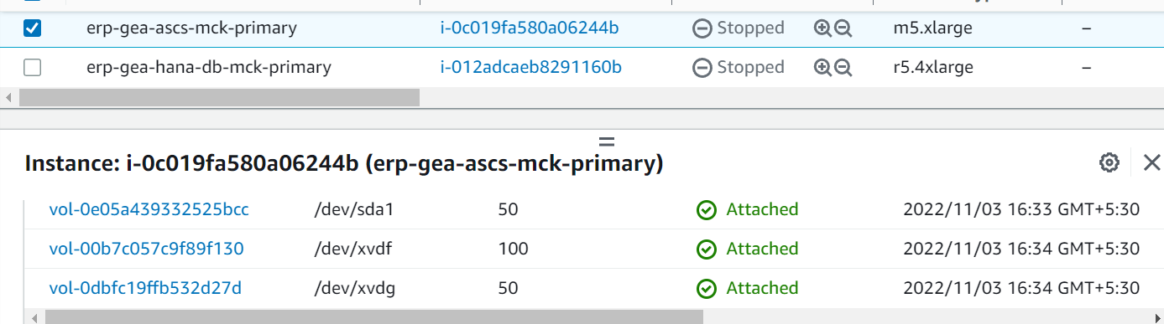

Security Groups:

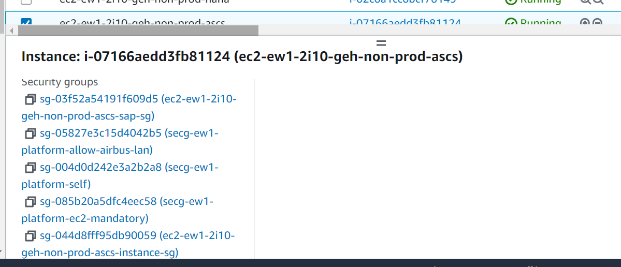

Similarly, SG, Volume groups can be found for other EC2 of the same system.

Primary and Secondary IPs: assigned to same ENI-

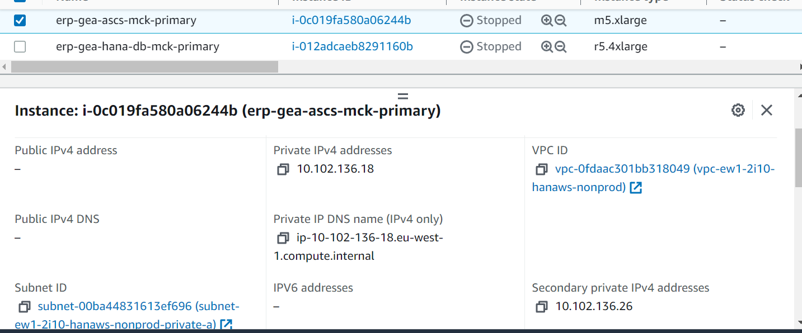

Route53 ANAME must be defined for secondary Ips also and reverse lookup address also.

# Jenkins jobs

<https://2i10-hana.jenkins.2b82-devops.aws.cloud.airbus.corp/job/2i10-arp-suse-gea/>

2i10-arp-suse-gea is the job name.

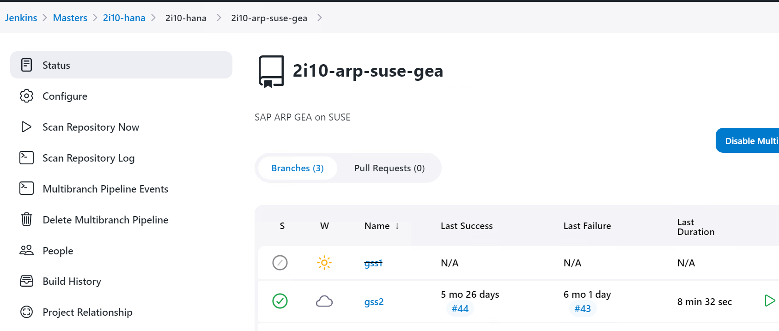

<https://2i10-hana.jenkins.2b82-devops.aws.cloud.airbus.corp/job/2i10-arp-suse-sr-jea/>

2i10-arp-suse-sr-jea

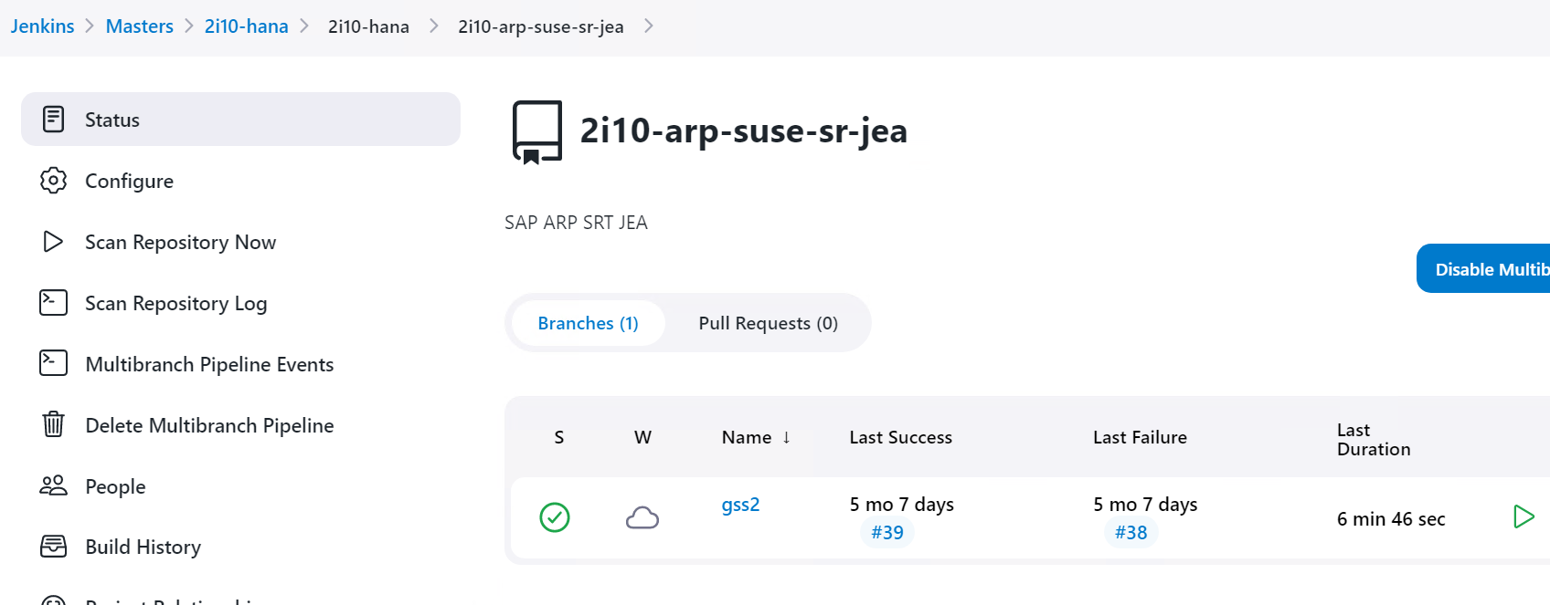

# How to build – A high level Overview

How to start the build – A very high-level procedure –

* Use main branch to pull the code locally on your system (Airbus LAN Windows Server).
* Use Visual Studio Code as editor and add folder to workspace to edit the required configuration files like tfvars, backend.tf and Jenkinsfile.
* Go to Jenkins CI/CD pipeline application and use an existing job definition to define a pipeline job. Access Jenkins using <https://2i10-hana.jenkins.2b82-devops.aws.cloud.airbus.corp/>
* Execute the Jenkins job and check the console outcome. You can also use Open Blue Ocean to run the job.
* Upon successful execution of Jenkins job, verify infrastructure defined and AWS SSM documents for systems.
* Enable SSM agent on EC2 instances
* Run required SSM documents in given sequence – follow repository specific documents stored into GDrive.

Use another document updated in Gdrive for more details on repository and SAP/HANA build process

Document Title: **Airbus PCP – SAP HANA deployment in AWS using IaC V1.2**

<https://docs.google.com.rproxy.goskope.com/document/d/1loeX72ju7hYWwYwcvcMDXEIJ9RQvonMc/edit?usp=share_link&ouid=100423008560575183693&rtpof=true&sd=true>

# Features Delivered

GEA - SAP Distributed ABAP System Build (ASCS and PAS on separate server). Use repository 2i10-suse and folder arp-gea to refer the code.

JEA – Standalone SAP router for testing in MCK account. Use 2i10-suse repository and folder sap-router-jea to refer the code. This setup is decided not to be used further due to cost optimization, SAPRouter and SAP Web Dispatcher is installed together on same host.

# SSM Documents for GEA

Run below 4 SSM documents in sequence -

1. 2i10-erp-gea-bootstrap-hana-instance
2. user_group_creation – Run SSM document to create user/group for application host together and then on HANA DB server separately.
3. 2i10-erp-gea-install-ascs-master-document
4. 2i10-erp-gea-install-hana-master-document
5. 2i10-erp-gea-install-pas-master-document

|  |
| --- |
| **SSM Docs** |
| 2i10-erp-gea-add_to_hosts |
| 2i10-erp-gea-bootstrap-hana-instance |
| 2i10-erp-gea-download-ascs-software |
| 2i10-erp-gea-download-hana-software |
| 2i10-erp-gea-download-pas-software |
| 2i10-erp-gea-execute-ascs-installation |
| 2i10-erp-gea-execute-hana-installation |
| 2i10-erp-gea-execute-pas-installation |
| 2i10-erp-gea-hana-post-installation |
| 2i10-erp-gea-install-ascs-master-document |
| 2i10-erp-gea-install-hana-master-document |
| 2i10-erp-gea-install-pas-master-document |
| 2i10-erp-gea-install-sap-aws-data-provider |
| 2i10-erp-gea-install-sap-packages |
| 2i10-erp-gea-mount-hana-disks |
| 2i10-erp-gea-mount-netweaver-disks |
| 2i10-erp-gea-prepare-hana-backup |
| 2i10-erp-gea-prepare-sap-installation-logs |
| 2i10-erp-gea-sap-hana-start |
| 2i10-erp-gea-sap-hana-stop |
| 2i10-erp-gea-sap-instance-start |
| 2i10-erp-gea-sap-instance-stop |
| 2i10-erp-gea-sap-netweaver-installation-pipeline |
| 2i10-erp-gea-sap-netweaver-start |
| 2i10-erp-gea-sap-netweaver-stop |
| 2i10-erp-gea-set-hostname |
| 2i10-erp-gea-set-sap-ascs-parameters |
| 2i10-erp-gea-set-sap-hana-parameters |
| 2i10-erp-gea-set-sap-pas-parameters |

# SSM Documents for GEH

Run below 4 SSM documents in sequence -

1. 2i10-erp-geh-bootstrap-hana-instance
2. user_group_creation – Run SSM document to create user/group for application host together and then on HANA DB server separately.
3. 2i10-erp-geh-install-ascs-master-document
4. 2i10-erp-geh-install-hana-master-document
5. 2i10-erp-geh-install-pas-master-document

|  |
| --- |
| **SSM Docs** |
| 2i10-erp-geh-add_to_hosts |
| 2i10-erp-geh-bootstrap-hana-instance |
| 2i10-erp-geh-download-ascs-software |
| 2i10-erp-geh-download-hana-software |
| 2i10-erp-geh-download-pas-software |
| 2i10-erp-geh-execute-ascs-installation |
| 2i10-erp-geh-execute-hana-installation |
| 2i10-erp-geh-execute-pas-installation |
| 2i10-erp-geh-hana-post-installation |
| 2i10-erp-geh-install-ascs-master-document |
| 2i10-erp-geh-install-hana-master-document |
| 2i10-erp-geh-install-pas-master-document |
| 2i10-erp-geh-install-sap-aws-data-provider |
| 2i10-erp-geh-install-sap-packages |
| 2i10-erp-geh-mount-hana-disks |
| 2i10-erp-geh-mount-netweaver-disks |
| 2i10-erp-geh-prepare-hana-backup |
| 2i10-erp-geh-prepare-sap-installation-logs |
| 2i10-erp-geh-sap-hana-start |
| 2i10-erp-geh-sap-hana-stop |
| 2i10-erp-geh-sap-instance-start |
| 2i10-erp-geh-sap-instance-stop |
| 2i10-erp-geh-sap-netweaver-installation-pipeline |
| 2i10-erp-geh-sap-netweaver-start |
| 2i10-erp-geh-sap-netweaver-stop |
| 2i10-erp-geh-set-hostname |
| 2i10-erp-geh-set-sap-ascs-parameters |
| 2i10-erp-geh-set-sap-hana-parameters |
| 2i10-erp-geh-set-sap-pas-parameters |

# SSM Documents for JEA

Run 2i10-jea-sr-setup-automation to build standalone router.

Before running master document – user/groups can be created manually.

user_group_creation – Run this SSM document on router host.

|  |  |
| --- | --- |
| 0 | 2i10-jea-sr-setup-automation |
| 1 | 2i10-jea-sr-prepare-setup-logs-command |
| 2 | 2i10-jea-sr-create-runtime-user-command |
| 3 | 2i10-jea-sr-set-hostname-command |
| 4 | 2i10-jea-sr-set-environment-variables-command |
| 5 | 2i10-jea-sr-packages-setup-command |
| 6 | 2i10-jea-sr-usrsap-volume-mount-command |
| 7 | 2i10-jea-sr-install-sap-aws-data-provider |
| 8 | 2i10-jea-sr-download-binaries-command |
| 9 | 2i10-jea-sr-set-usrsap-ownership-to-runtime-user-command |
| 10 | 2i10-jea-sr-create-csr-command |
| 11 | 2i10-jea-sr-init-routtab-logs-tracefile-command |
| 12 | 2i10-jea-sr-sap-host-agent-setup-command |